## Setup:

You will need a Power BI account for this demo. If you do not have an account, you can sign up for free at <http://powerbi.com>. Load the [Power BI Desktop](http://powerbi.microsoft.com/desktop), as you will use it along with the Power BI Web Service. You will need a Windows machine or virtual machine in order to run the Power BI Desktop. If you are using a Mac, you can use tools such as Basecamp, Parallels, or your favorite virtualization tool to attach to an instance of Windows with Power BI. You can also load the [Mobile app](http://powerbi.microsoft.com/en-us/mobile/) if you want to show how the reports you create are immediately available to mobile app users.

## Introduction:

Data is the food that feeds civic technologists. With more open data available than ever before, there is great opportunities for governments, NGO’s, social entrepreneurs, interested citizens, and civic technologists to use data from many sources to:

* Analyze civic issues and challenges
* Pinpoint opportunities for change
* Provide insights to inform policy
* Tell a story of a civic priority

Enter Power BI. Power BI allows you to quickly attach to a wide variety of data sources. And from there, you can create visualizations, derive insights, and share intelligence in minutes with no special data skills required.

## Locating and accessing data:

In this optional part of the workshop, you will use Power BI to examine the development of greenhouse gas emissions using visualizations, and derive insights into the following topics:

* + Greenhouse gas by country since 1990
  + Sources of electricity by country
  + Forest areas by geography

To start, we will open the Power BI Desktop and use it to access data from the web, build a data model, create reports, and share what you created by publishing it to the Power BI web service.

*In Power BI Desktop with the blank report page, from the Home tab, select Get Data.*

*Show the wide selection of data sources that are available.*

*Choose Web.*

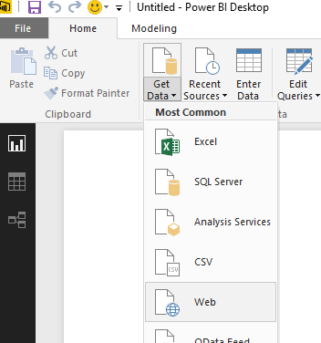

The World Bank is a great source of economic and environmental data. The data is free and open and used by organizations looking to understand development issues.

*Go to* [*http://data.worldbank.org/*](http://data.worldbank.org/) *and explore some of the available data sets.*

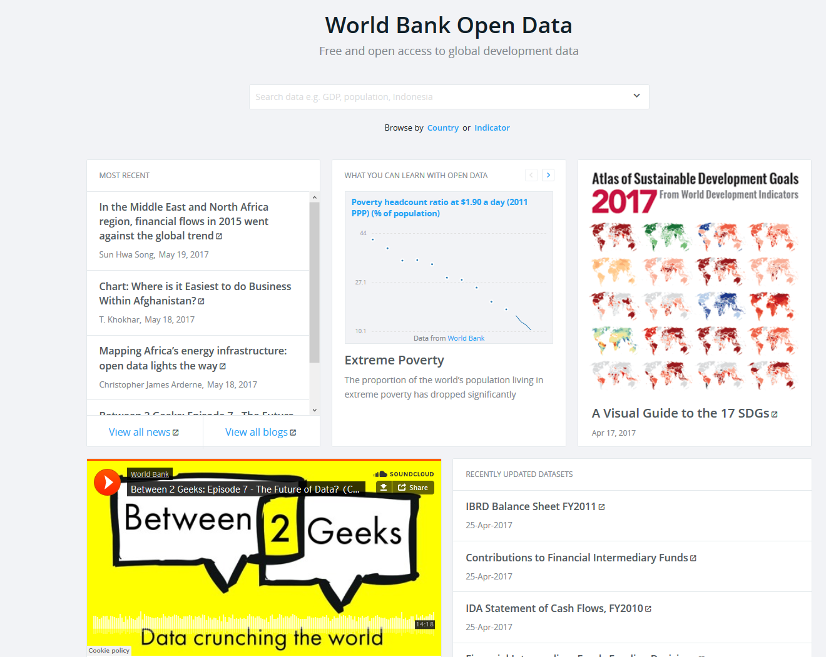

Power BI can easily access this data in a few steps. You just need to follow the data link that holds the data you want to work with, and copy that link into Power BI. In this example, we are going to look at Climate Change data.

*In the search box, type Climate*

*Select* ***Climate Change*** *from the list of suggested terms.*

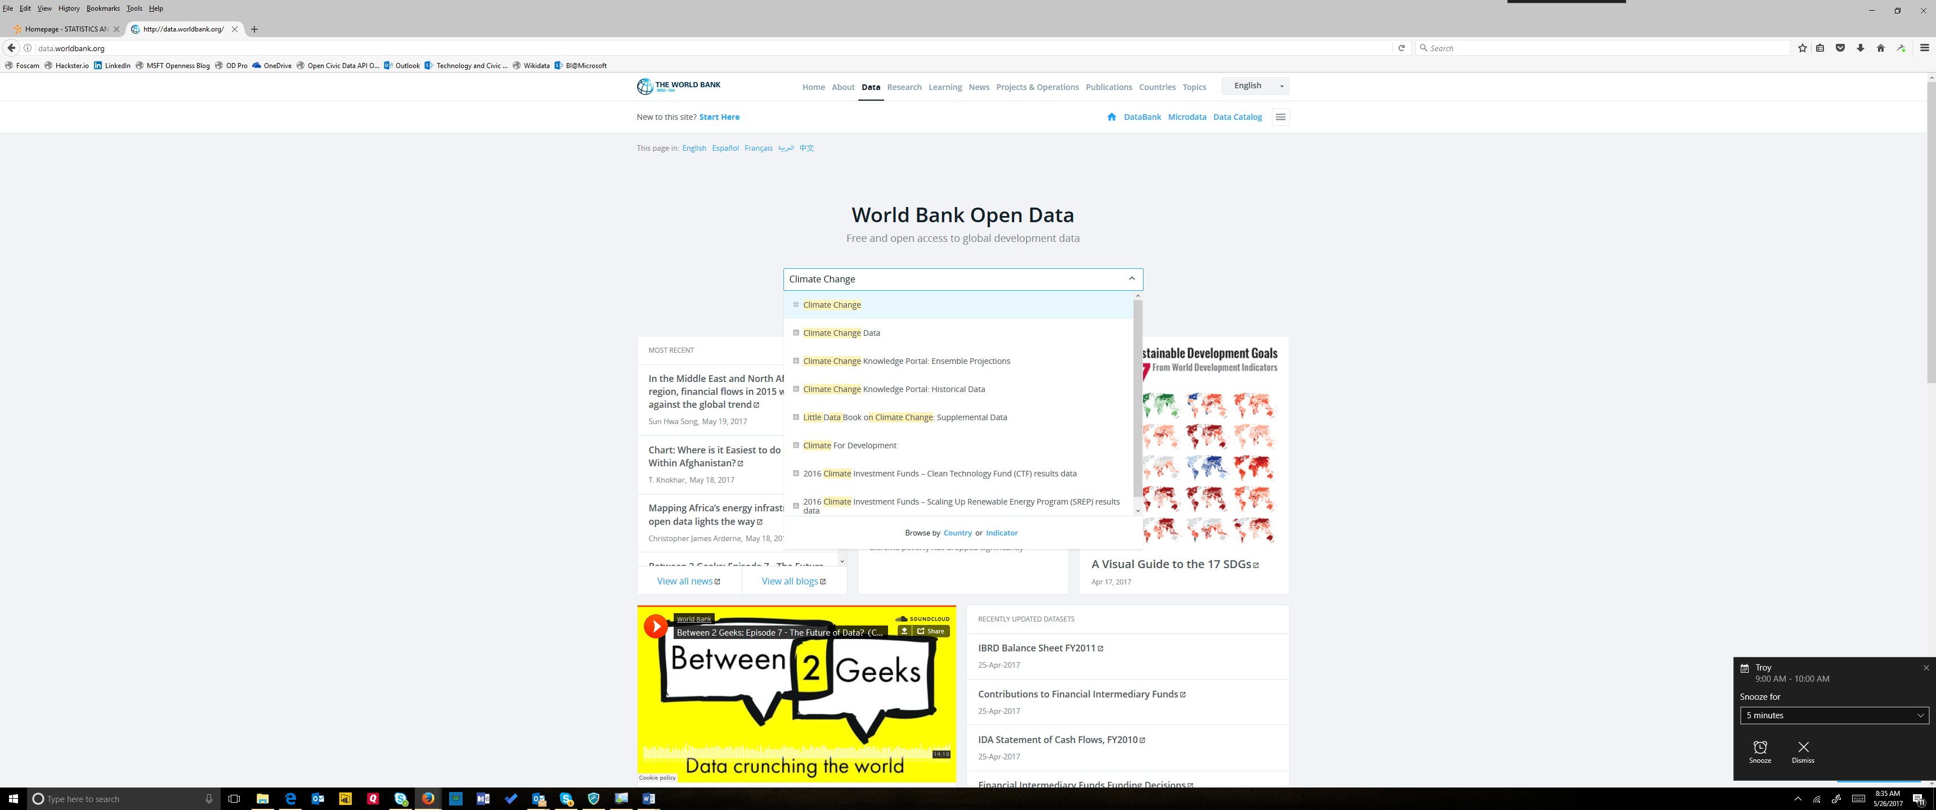

*Click on red Download box.*

*You will see three download options: Excel, XML, and CSV.*

*Right-click on Excel, then select Copy Shortcut. This represents the web address of an Excel table.*

Now, just by pasting the URL in the Power BI desktop, you can start using this data directly off the World Bank data site.

*Switch back to the Power BI Desktop*

*Paste the shortcut into the URL field of the From Web dialog.*

*Click on OK.*

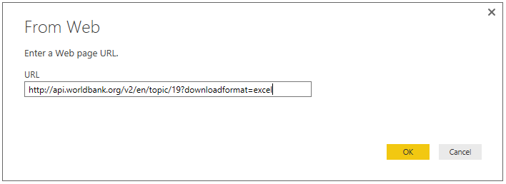

## Queries:

Next, the Query functionality of Power BI Desktop will go to work. Query contacts the Web resource, and the Navigator window returns what it found on that Web page. In this case, it found three tables. We’re interested in two of the tables, so we select them from the list. The Navigator window displays a preview of the data.

*The Navigator dialog will appear.*

*Select the Data and Metadata – Countries data sets.*

*Click on Edit.*

*Power BI Desktop will show the data in the Query Editor.*

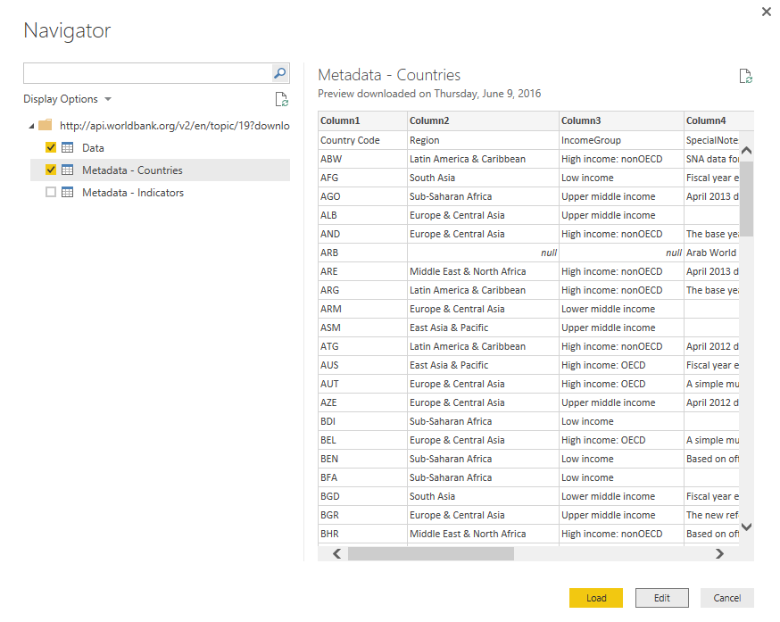

At this point we can edit the query in the Power BI Desktop before loading the data, by selecting Edit. This both connects you to the data source and allows you to make transformations that can be re-used.

*Click on Edit*

Now we shape the data to meet our needs. We can access the transformation tools by either leveraging the Transform ribbon or using right click menus. We will start by using the first row of our data set as headers.

*Below Queries [2], select the Metadata – Countries query.*

*Expand the menu in the top left corner of the data table and select Use First Row As Headers.*

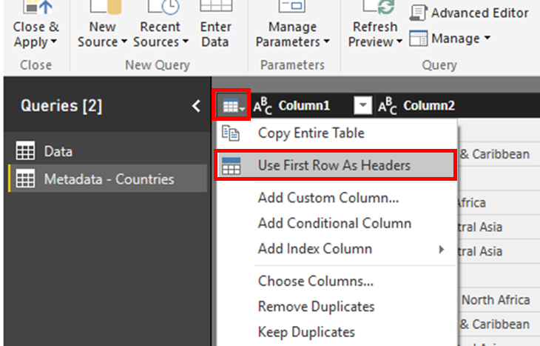

Next, we will remove the extra rows at the top of the table, as we won’t need them.

*Below Queries [2], select the Data query.*

*Expand the menu in the top left corner of the data table and select Remove Top Rows.*

*Remove the top 3 rows.*

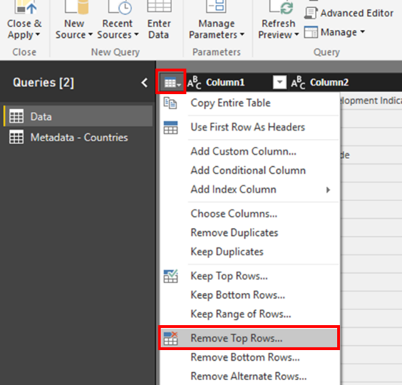

Take a look at the Applied Steps pane on the right. The steps you take are recorded by the Query Editor, and each time this query connects to the data source those steps are carried out so that the data is always shaped the way you specify.

Now that we removed the top 3 rows, we want to make sure the first row is the header in our table.

*Expand the menu in the top left corner of the data table and select* ***Use First Row As Headers****.*

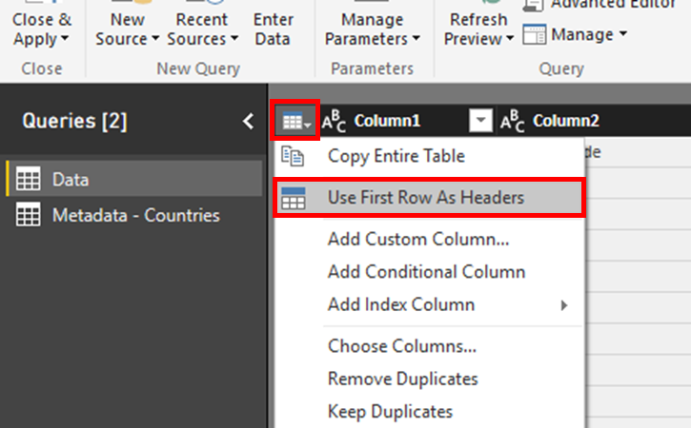

Now take a look at the data itself. You can see that our data set has a column for each year from 1990 to 2015. Each of the columns contains the climate change values for each year.

As we analyze this data, it would be better to have these columns as rows and with the Unpivot function, you can easily do this. With the Unpivot function, you can transform the selected columns into attribute-value pairs where columns become rows.

*Select all the year columns (1990 to 2015) of the data table. Use the SHIFT key to multi-select.*

*Right-click on one of the column headers and select Unpivot Columns*

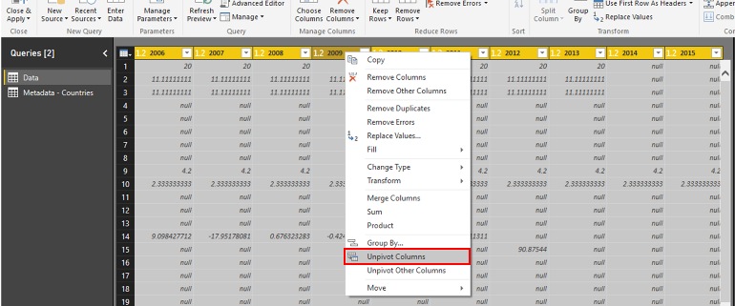

Now we have two columns, one named Attribute and one named Value. Rename the Attribute column to what it really represents: Year.

*Right-click on the new column titled Attribute and select Rename.*

*Rename the column to Year.*

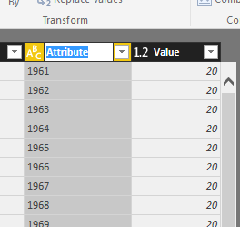

You can also pivot columns, and create a table that contains aggregated values for each unique value in a column. In our example, we want to create a new column for each of the indicators (like CO2 emissions) in the data set.

*Click on the column header Indicator Name to select the entire column.*

*From the Transform ribbon, select Pivot Column.*

*Select Value to pivot the column on.*

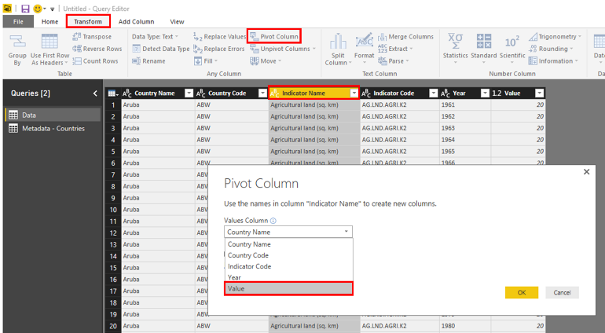

We are done shaping the data, so now you can apply the query changes and close the Query Editor.

*From the Home ribbon, select Close & Apply to apply the query changes.*

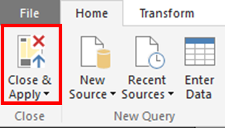

In Power BI, there are several ways of viewing your data and its structure. In Power BI Desktop, you can switch between Report View, Data View, and Relationship View by selecting the icons in the left hand navigation bar.

When you import multiple tables, chances are you’re going to do some analysis using data from all those tables. Relationships between those tables are necessary in order to accurately calculate results and display the correct information in your reports. Power BI Desktop will attempt to find and create relationships for you.

*On the left pane, switch to the Relationships view in Power BI Desktop.*

*Notice that Power BI has auto-created a relationship between the two data tables on the Country Code field*

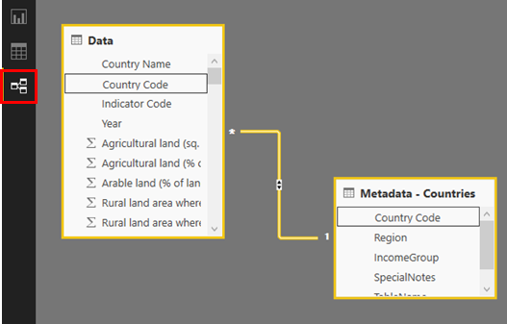

## Reports:

In Report View, you can create multiple report pages, each with multiple visualizations. Report View provides a very similar design experience to a report’s Editing View in the Power BI service. You can create new visualizations, move them around, copy and paste, etc.

*Switch to the Report view in Power BI Desktop using the report icon on the left. You should see a blank report page.*

*In the Fields pane on the right, expand the fields in the Data table.*

*Select the field CO2 emissions (kt). You can hover over a field or resize the Fields pane to see the full names.*

*A bar chart will appear as the default visualization. Note that Power BI chooses a default visualization based on the data.*

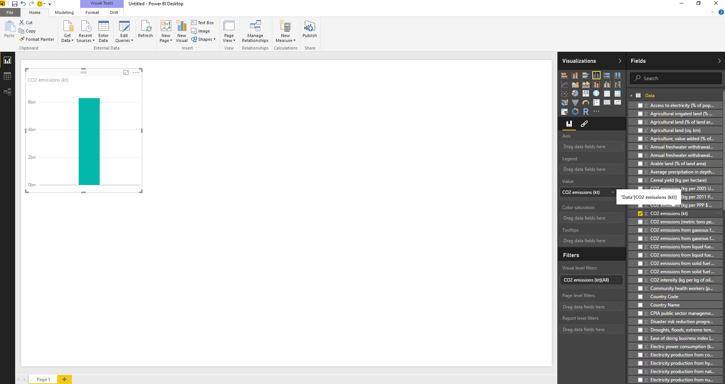

To change the type of visualization, you can select it from the Visualization group in the ribbon or you can right click and select a different one from the Change visualization type icon.

*Change the visualization to Card.*

*Move the card to the top left area of the report page.*

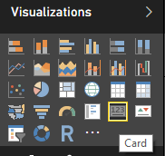

Filters are key in Power BI. They allow you to visualize just the data you want to focus on. Using the Filter pane, you can view, set, and modify page, report, and visual-level filters. Let’s apply a filter on Year for this visual. In our data set, 2011 is the most recent year for which CO2 emission data is included.

*Drag and drop the field Year into Visual level filters.* 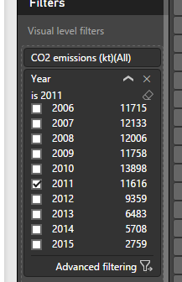

*Select 2011 in the list of years.*

Let’s add another visualization to our report. I want to see how CO2 emissions have developed over the years. For this type of data, an area chart is a good option.

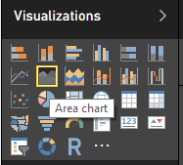*Click on an empty area on the report page.*

*Select the fields CO2 emissions (kt) and Year from the Data table.*

*Change the visualization type to Area chart.*

*Resize the chart and move it next to the card visualization.*

*Using the menu (…) at the top right of the visualization, select Sort By Year A->Z.*

*It should look like this:*

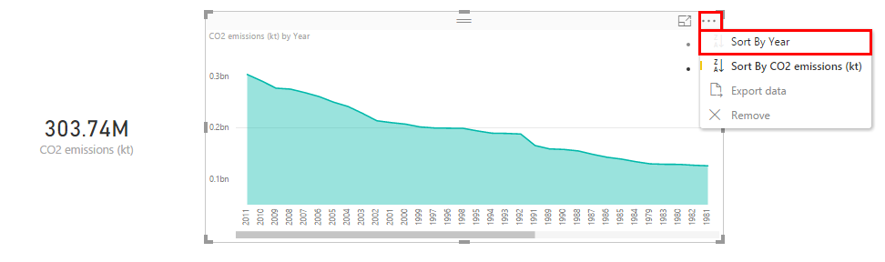

Let’s add another visualization to our report, showing CO2 emissions by regions. We will use a treemap visual for this. Treemaps are charts of colored rectangles, with the size of a rectangle representing the value. They are very useful for categorical and hierarchical data. Government data, indeed all types of civic data, are often analyzed using categorical and hierarchical data, especially as it relates to geography.

*Click on an empty area on the report page, below the card visual.*

*Select the field Region from the Metadata – Countries table.*

*Select the field CO2 Emissions (kt) from the Data table.*

*Change the visualization into a Treemap.*

*Resize and move the visualization to the bottom left area of the report page.*

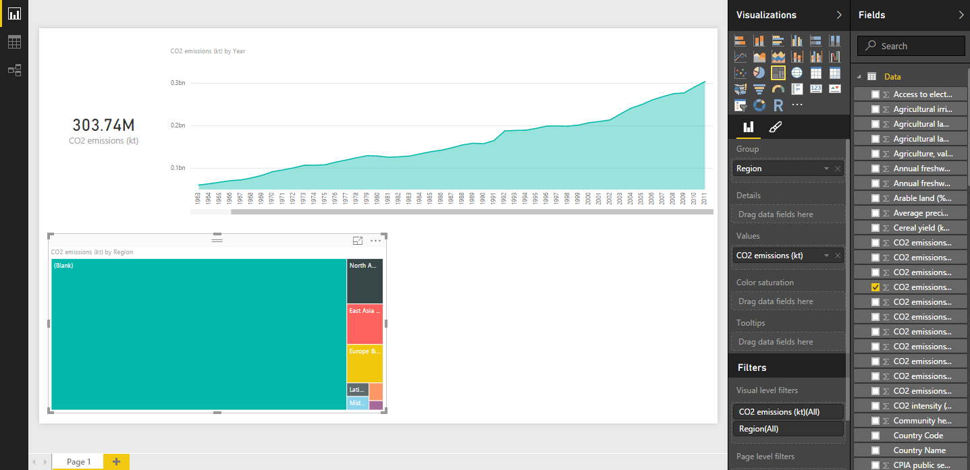

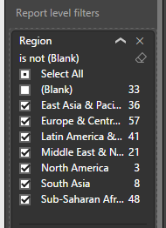The data appears to be overwhelmed by (Blank) values for Region in our data set, let’s filter these out. Using another filter, this time at the Report level, we will remove all regions with a blank value.

*Drag and drop the field Region from the Metadata – Countries data table to Report level filters.*

*Select All, then uncheck Blank to filter out any data records that do not have a region assigned.*

One of the key reasons for using Power BI to communicate with your data is that the different visualizations interact with each other. Explore this by selecting a region in the treemap visual and see what happens to the other visuals.

*Click on region East Asia & Pacific in the treemap to show the interactivity with the other two charts.*

*Click on region East Asia & Pacific again to clear the selection.*

This treemap is nice, but if I’d like to include more data in my visualization. Let’s try a bar chart.

*Select the treemap visualization.*

*Change the visualization into a Stacked Bar Chart.*

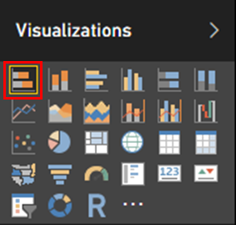

Color saturation is a good way to show density or degree of data. Let’s show the forest area for each region in the same chart as the color saturation. The World Bank Organization notes that healthy forests absorb immense amounts of carbon dioxide. However, when deforestation happens, often due to logging or converting land for agricultural use, forests can also release damaging greenhouse gases into the atmosphere.

*Drag the field Forest area (sq. km) into the Color saturation property.*

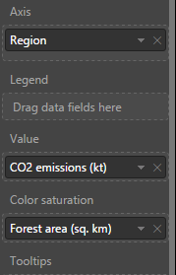

Now sort the chart by total CO2 emissions.

*Using the menu (…) at the top right of the visualization, select Sort By CO2 emissions (kt) Z->A.*

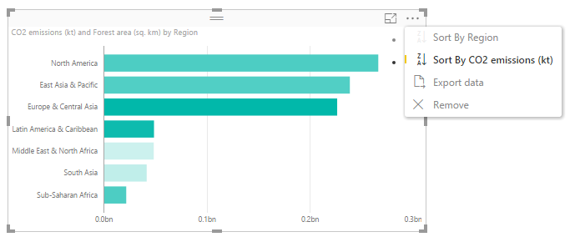

What we see now is that the darker shaded bars like Europe & Central Asia or Latin America & Caribbean have larger forest areas, whereas the lighter shaded bars like Middle East & North Africa or South Asia have less forest areas.

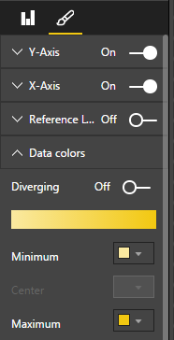You can customize the color options for the chart to. Instead of the default color, I want to see this in a more yellow gradient color.

*Switch to the Format menu (pencil icon) for the bar chart visual.*

*Expand the Data colors section.*

*Change the Minimum and Maximum values to a different color.*

Another common need for civic data is the need to drill through for more detail. Visualizations like treemaps or bar charts can be hierarchical and they support drill through navigation. Let’s take a look at how this works.

*Switch to the Fields menu (bars icon) for the bar chart visual.*

*Drag the field Country Name below Region into the Group area.*

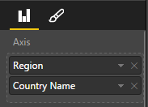

There are 2 different ways to drill down (and up) in your visualization. To enable drill down, select the arrow icon in the top right corner of the visualization. When the icon is dark, drill is enabled.

When I click on a region, I will now drill down into the countries for that region. Using the arrows on the top left, I can drill down all fields at once, or drill back up.

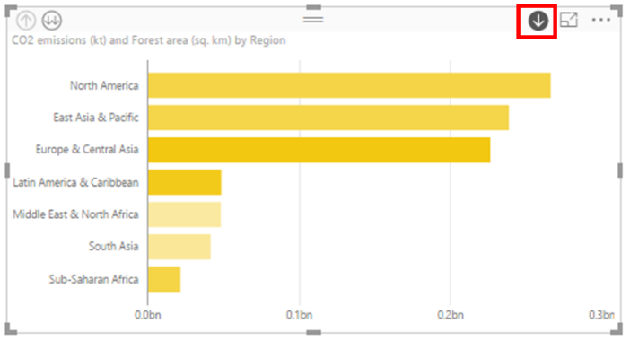

*Click on the drill mode arrow at the top right of the visual.*

*Click on East Asia & Pacific to see all the countries that are part of that region.*

*Click on the arrow up to drill up to the region level.*

## Mapping:

Since much of civic data is geographic, mapping is key to communicating and analyzing data. There are several ways of exploring geography (including the new ESRI visualizations). In this workshop, we are going to look at the basic map. We will add another to our report a map showing CO2 emissions around the world.

*Click on an empty area on the report page.*

*In the Visualizations pane, choose Map.*

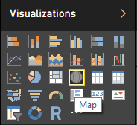

We want to see CO2 emissions by country, with the option to filter by region.

*Drag and drop the field Country Name from the Data table to the Location property.*

*Drag and drop the field CO2 emissions (kt) from the Data table to the Size property*

*Drag and drop the field Region from the Metadata – Countries table to the Legend property.*

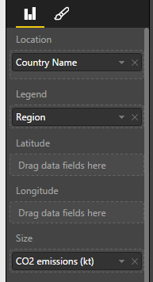

At this point, we have a report with 4 different visualizations that interact with each other. I can resize and move the visualizations around to my preference.

Now that we have a Power BI Desktop report, I can share it with others on the Power BI service. There are a few ways to share your work in Power BI Desktop. You can publish to the Power BI service, you can publish the reports to the web for public consumption, you can upload the PBIX file directly from the Power BI service, or you can save the PBIX file and send it like any other file.

When you publish a report to the Power BI Service for the first time, you are shown an option to choose the report's destination workspace. The list includes all workspaces that you have access to as well as the My Workspace. This allows you to publish to shared workspaces, making the report immediately available to its members.

*On the ribbon, select Publish.*

*When prompted, sign in to the Power BI service.*

*Select My Workspace as destination, then click Publish.*

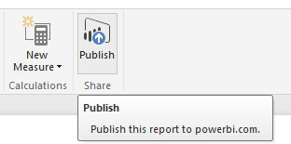

*Once the file has been published, you can open it in the Power BI service, or you can select Get Quick Insights to see this amazing feature.*

*Click on Open ‘ClimateChangeDemo.pbix’ in Power BI, and sign into your account.*

As you just saw, it is pretty easy to build reports from scratch, but often there are insights in your data that may not be obvious. This is where the Quick Insights functionality in Power BI can help you.

A browser window opened which connected me to the Power BI service. The ClimateChangeDemo report and dataset have been uploaded and I can use it to create a dashboard and share it with others.

*In the Power BI service, under Reports, select the ClimateChangeDemo report.*

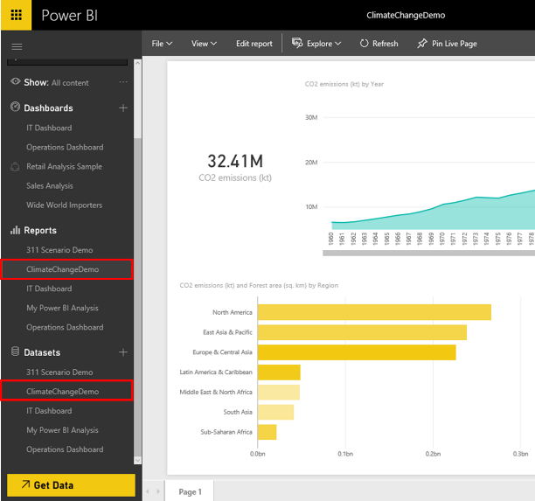

Now, you can also create a dashboard. A dashboard cannot, today, be published publicly to the web. It is meant to share across your organization. With dashboards, you can take visuals from multiple reports, web content, video content, etc. and bring it all together. Let’s create a new dashboard by pinning visuals from the Climate Change report to it. First, we will pin the CO2 emissions card to a new dashboard.

*Use the pin icon on the CO2 emissions (kt) card to pin it to the dashboard.*

*Choose New dashboard and name the new dashboard Climate Change Demo.*

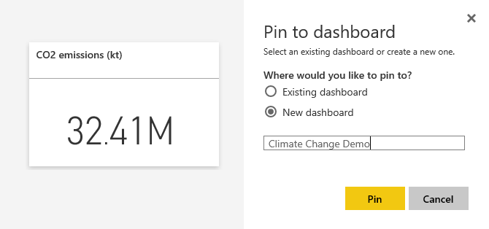

Next, we will pin additional visuals that I want to keep an eye on to my dashboard.

*Pin the remaining visuals to the existing dashboard Climate Change Demo.*

*Under Dashboards, select the ClimateChangeDemo report.*

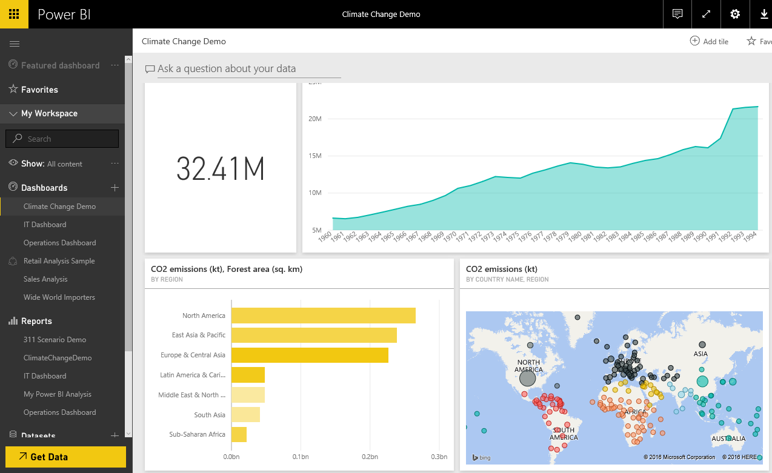

Natural Language Query:

In Power BI, we have additional capabilities, like natural language query. We can simply ask a question and Power BI will find the answer and visualize the data for us. As we type, Power BI will suggest terms for us to use in the question, based on the underlying data set. We can easily operationalize this new insight by pinning the chart to our dashboard.

*Place the cursor in the field Ask a question about your data at the top of the dashboard.*

*Enter total greenhouse*

*Accept the suggested term total greenhouse gas emissions (% change from 1990)*

*Add to the question* ***total greenhouse gas emissions (% change from 1990) by year as line for usa***

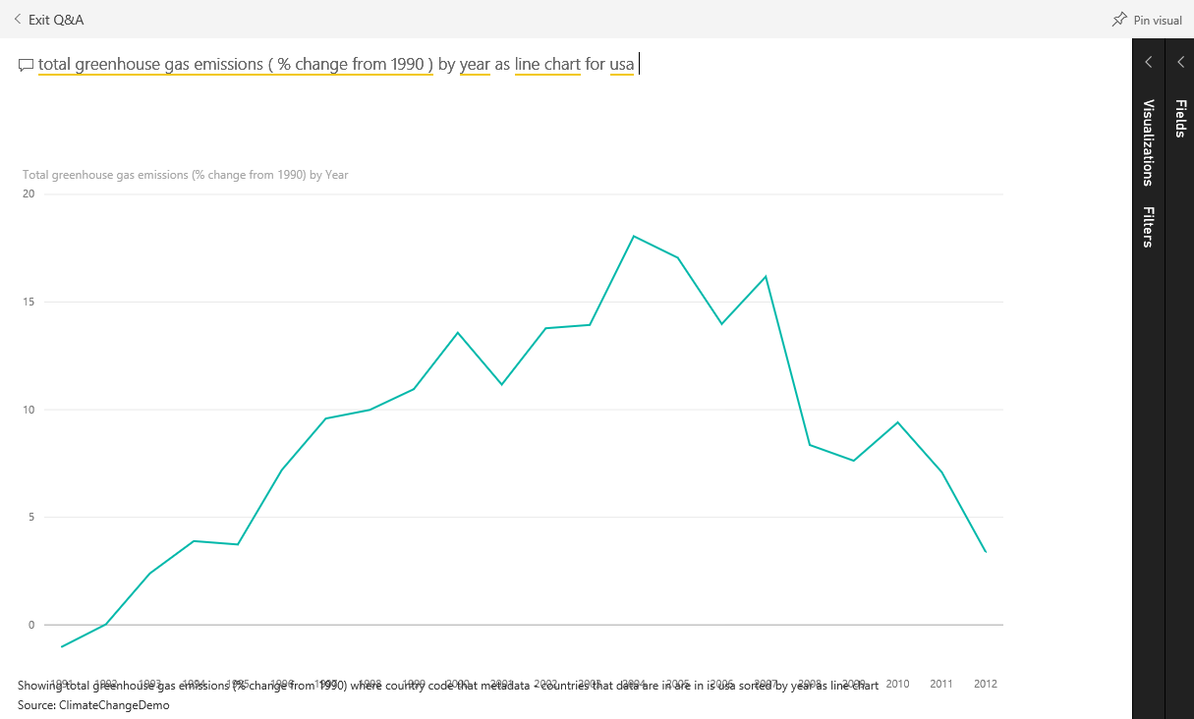

*Pin the chart to the dashboard.*

Mobile:

If you have Power BI loaded on your phone, you can go through this part of the workshop, showing the mobile features of Power BI. You can access your data on your iPhone, Android, or Windows device without doing anything special.

*Launch the Power BI app on your iPhone.*

*Sign in with your Microsoft Power BI account.*

*Select the Climate Change Demo dashboard and scroll through the visualizations.*

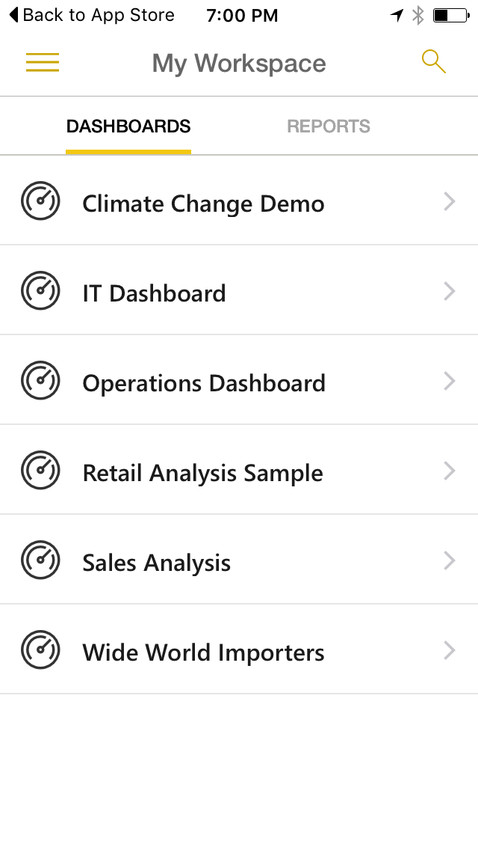

You can scroll through the tiles of your dashboard. All the tiles appear the same size, and they're arranged one after another from top to bottom.

*Scroll through the tiles.*

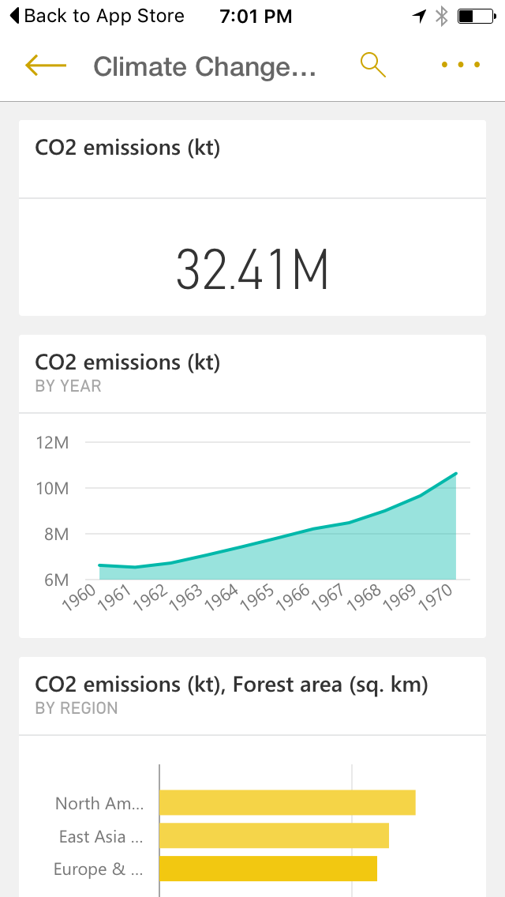

*Interact with the chart by moving the vertical line from left to right.*

You can also annotate and share a report with someone else through text or email. When you share a snapshot of a tile from the mobile app, your recipients see the snapshot of the tile exactly as it was when you sent the mail. They can't open the dashboard. You can send snapshots of tiles to anyone — not just colleagues in the same email domain.

*Annotate the chart by highlighting a drop or a spike.*

*You can share the chart with your annotations easily by clicking on the share button on the top right hand side.*

*Go back to the main dashboard.*

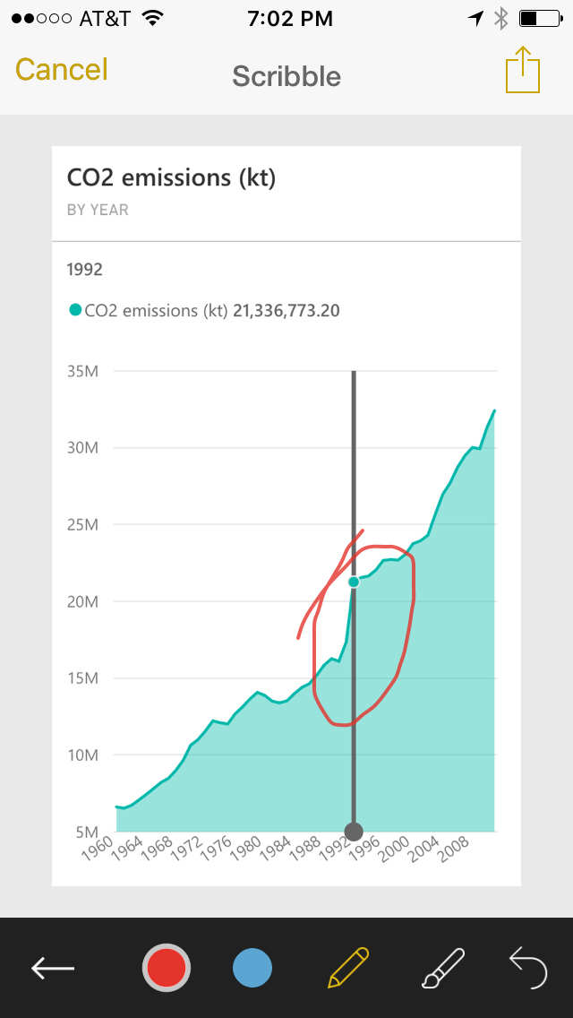

Of course, there is much more that you can do with Power BI and open data from government, business, and NGO’s. In order to get started in the quickest way possible, watch the short videos at: <https://powerbi.microsoft.com/en-us/guided-learning/powerbi-learning-0-0-what-is-power-bi/>